# Download TCP-H

* Go to <https://www.tpc.org/tpc_documents_current_versions/current_specifications5.asp>

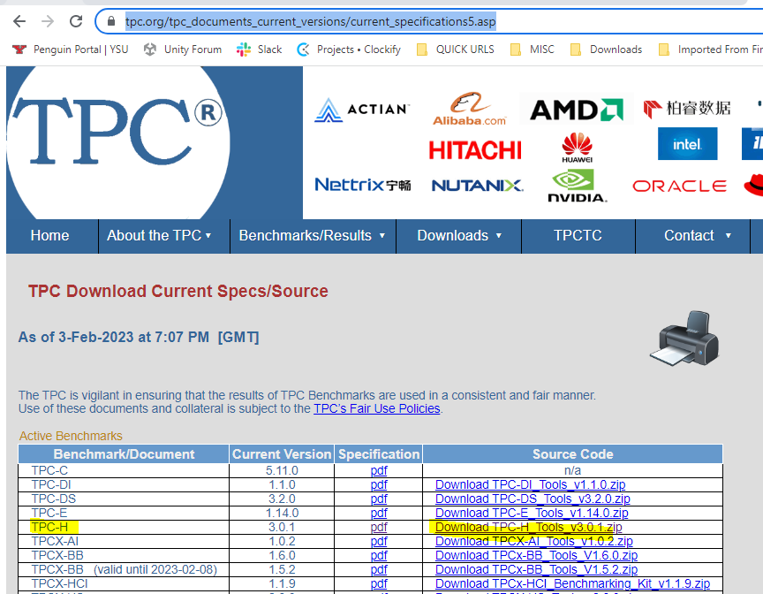

* Select TCP-H and provide details, it will send a link to provided email Id

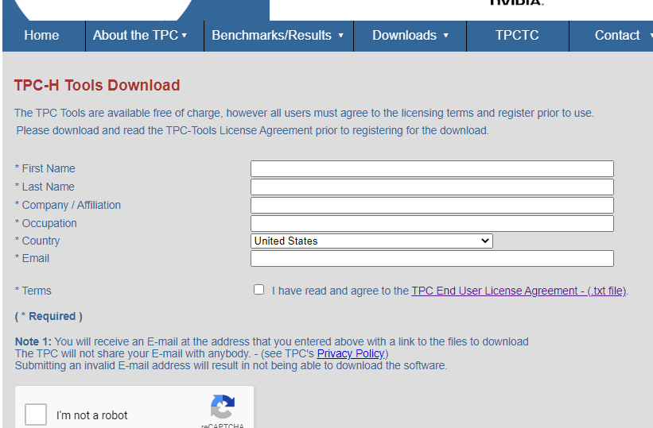

* Click the link sent in email, it will open a page where we can copy the URL for downloading file.

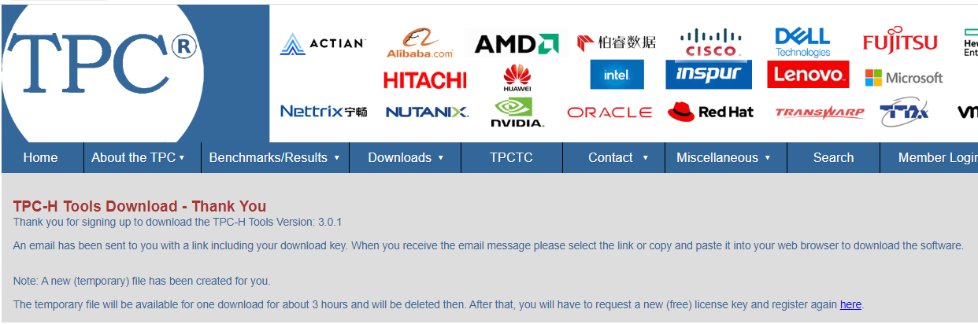

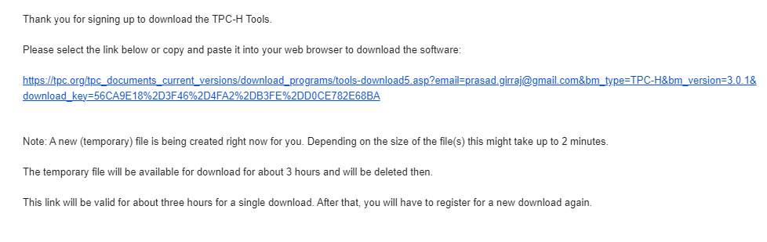

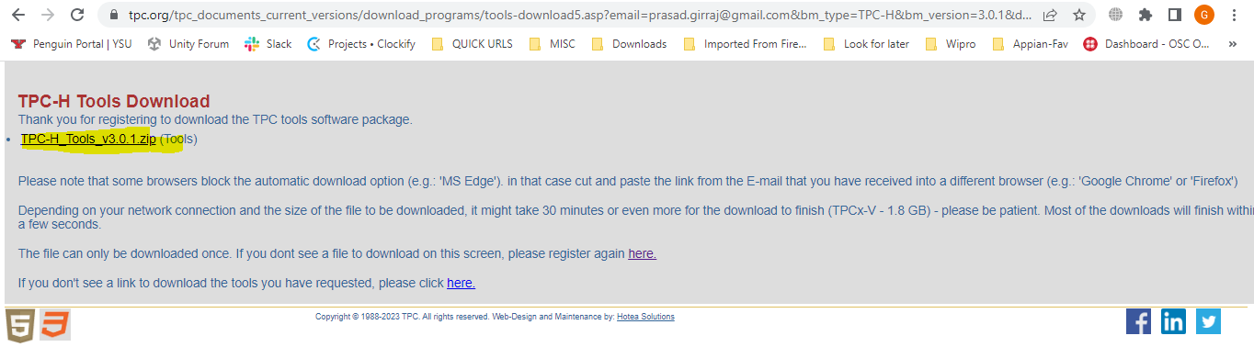

* One we get URL from above page. We can execute wget command. As this URL has whitespace, we need to enclose the URL in double quotes.

Also, downloaded file has weird name with last portion of URL string so we use –content-disposition to take server suggested name.

Note: This URL can be used only once for downloading the file. If you need to download it again, you need to register it again TCP website.

$ wget --content-disposition <https://www.tpc.org/tpc_documents_current_versions/download_programs/tools-download-files5.asp?email=prasad.girraj@gmail.com&benchmark=&bm_version=3.0.1&bm_type=TPC-H&type=Tool%20%20&download_key=56CA9E18-3F46-4FA2-B3FE-D0CE782E68BA>

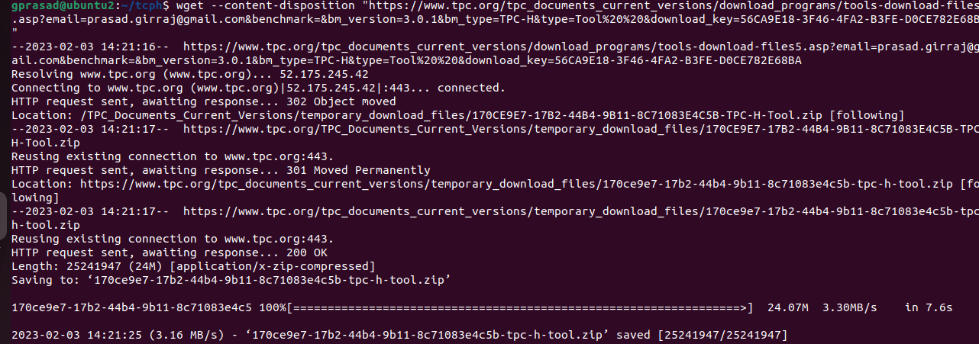



# Unzip folder

$unzip <filenamee>

If unzip command not found, install it first.

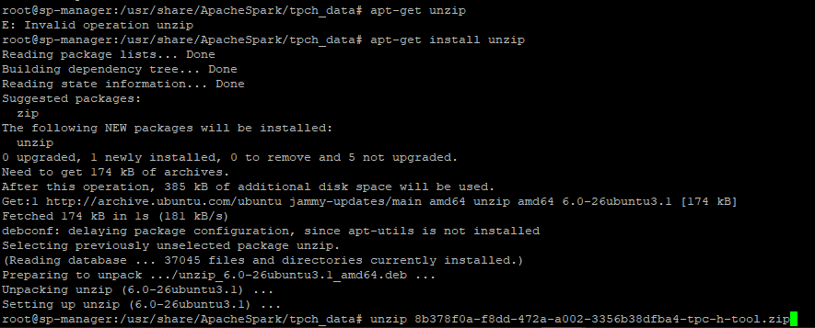

# Copy makefile.suite

$ cd “TPC-H V3.0.1”/dbgen

$cp makefile.suite makefile_ubuntu

# Set parameter in makefile

Set parameter CC, DATABASE, MACHINE, WORKLOAD as shown below

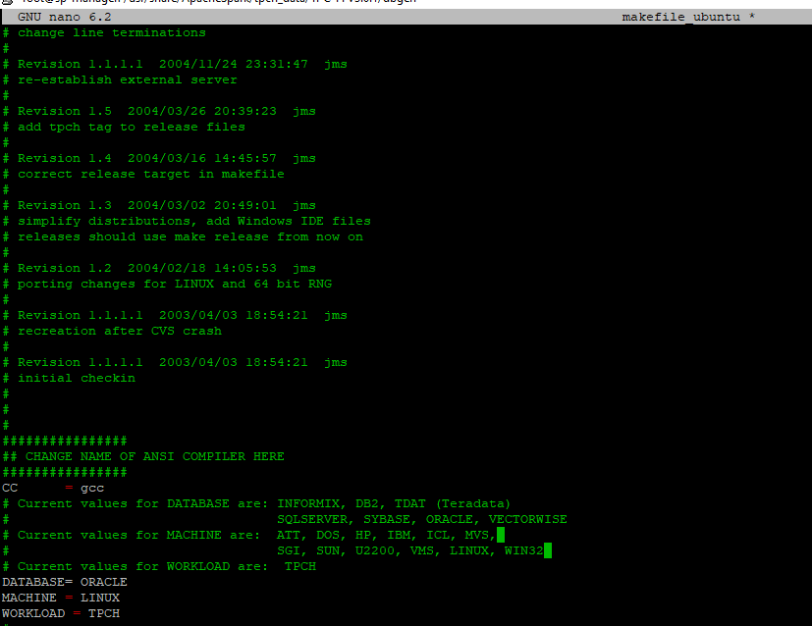

# Compile

$ make -f makefile_ubuntu

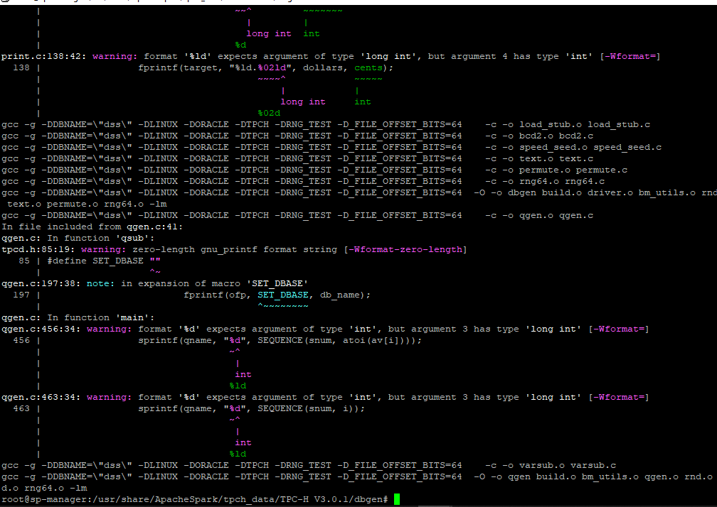

After this, dbgen is install. Now, we can generate data.



# Generate data (100 MB)

$ ./dbgen -s 0.1



# Verify Generated tables list

$ ls *.tbl



# Reference

<https://github.com/meeeejin/til/blob/master/benchmark/how-to-install-tpch-for-pgsql.md>

<https://github.com/YSU-Data-Lab/TPC-H-Skew>